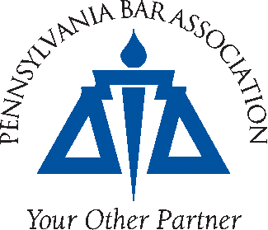

NOMINATION FOR

2018 CHRISTIANSON AWARD

The Public Utility Law Section of the Pennsylvania Bar Association is seeking nominations for its annual Christianson Award. This award will be presented to an individual, or on behalf of an individual, at the 2018 Public Utility Bench Bar Conference, sponsored by the Pennsylvania Bar Institute, on May 24, 2018.

THE NOMINATION DEADLINE IS MARCH 23, 2018

The recipient of the Christianson Award will be an individual who has made an outstanding contribution in the area of public utility law in the Commonwealth of Pennsylvania. Nominees must satisfy the following criteria as set forth by the Public Utility Law Section:

The honoree is to be an individual who has made an outstanding contribution to the development, improvement or furtherance of the profession of public utility law in Pennsylvania. The award may be given for some past or current activity by the honoree, or for the life's work of the honoree. The Section Council shall solicit nominations from the membership with an explanation of the basis for honoring the nominated on an annual basis. The award will be presented in conjunction with a bar association, educational or other event generally attended by members of the section.

Previous award recipients:
2006 - The Honorable Robert A. Christianson
2008 - Philip F. McClelland
2010 - Joseph J. Malatesta, Jr.
2012 - Irwin A. “Sonny” Popowsky
2014 - Herbert R. Nurick
2016 – Johnnie E. Simms
2017 - William R. Lloyd, Jr.

Nominations must be submitted by close of business March 23, 2018. Nominations may be made on the attached nomination form or in any manner that includes all of the information from the nomination form. Photocopies of the nomination form are acceptable. Your nomination can be submitted in one of three ways: (1) sending a completed nomination to Pamela Kance at the Pennsylvania Bar Association, 100 South Street, P.O. Box 186, Harrisburg, Pennsylvania 17108; (2) faxing a nomination to the PBA at facsimile number (717) 238-7182; or (3) electronically completing the nomination form by going to the PBA website: http://www.pabar.org/site/Members/Sections/Public-Utility-Law-Section/Awards

If you have any questions or need additional information, please contact Pamela Kance at (800) 932-0311, ext. 2243.

